Air Board Assembly Guide

MIT CityFARM

These are instructions on how to assemble an Air Quality Sensor Board using various air quality sensors, and an Arduino, which will be programmed to send data through a serial port.

For this example, 6 sensors will be used, one Arduino and a Grove shield, as well as a custom made acrylic case in which the sensors and the Arduino will be mounted.

**Parts and equipment needed:**

* Sensors (Links to suppliers provided at the reference section):

- CO2 sensor (COZIR-AMB 5,000ppm CO2) [1]

- Temperature and Humidity sensor (DHT22) [2]

- Light, UV, IR Digital sensor (based on SI1145) [3]

- Water Temperature probe (based on DS18B20) [4]

- O2 Gas sensor (based on Alphasense O2) [5]

* LED strip (optional, based on WS2812B) [6]
* Voltage Level Translator (based on TXB0104) [7]
* 1 Arduino Uno.
* 1 Grove Shield [8] and Grove cables(If sensors use the Grove connectors, as in this example).

* 18X6” 1/8” clear acrylic sheet.
* 2 4/40 1” screws, 12 4/40 ½” screws, 14 4/40 nuts.
* DXF files supplied (CAD files included) [9].
* Access to a Laser Cutter.
* Soldering Iron.
* Jumper wires.

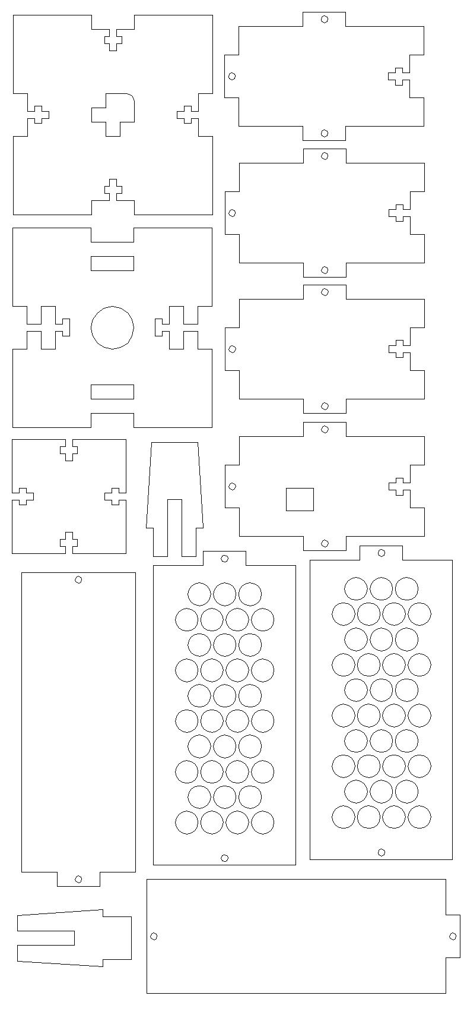Steps:

1. Cut acrylic pieces from DXF files.

The DXF files can be downloaded from Github *(“/Air Sensors/CAD/DXF Export T-Slots eighth inch”*), as shown below:

Parts needed:

1 – base-top

1 – base-bottom

1 – base-side

1 – base-side-usb

2 – base-side-no-hole

1 – top

1 – prong_1

1 – prong_2

2 – column-sensor-side

2 – column-side

2. The voltage level translator converts the 5V TTL logic from the Arduino to the 3.3V TTL required by the COZIR CO2 sensor. If using a Grove shield, consider using a Grove cable for GND, 5V, TX and RX, which will make wiring easier. Connect the voltage level translator to the sensor as following:

Macintosh HD:Users:gkolotelo:Documents:Programming:University:MIT:CityFARM:For-Guide:for-guide.PDF

So as to supply the COZIR CO2 sensor with 3.3V (Supplied from the Arduino), and allow serial TTL communication with the proper voltages for each device. Example:

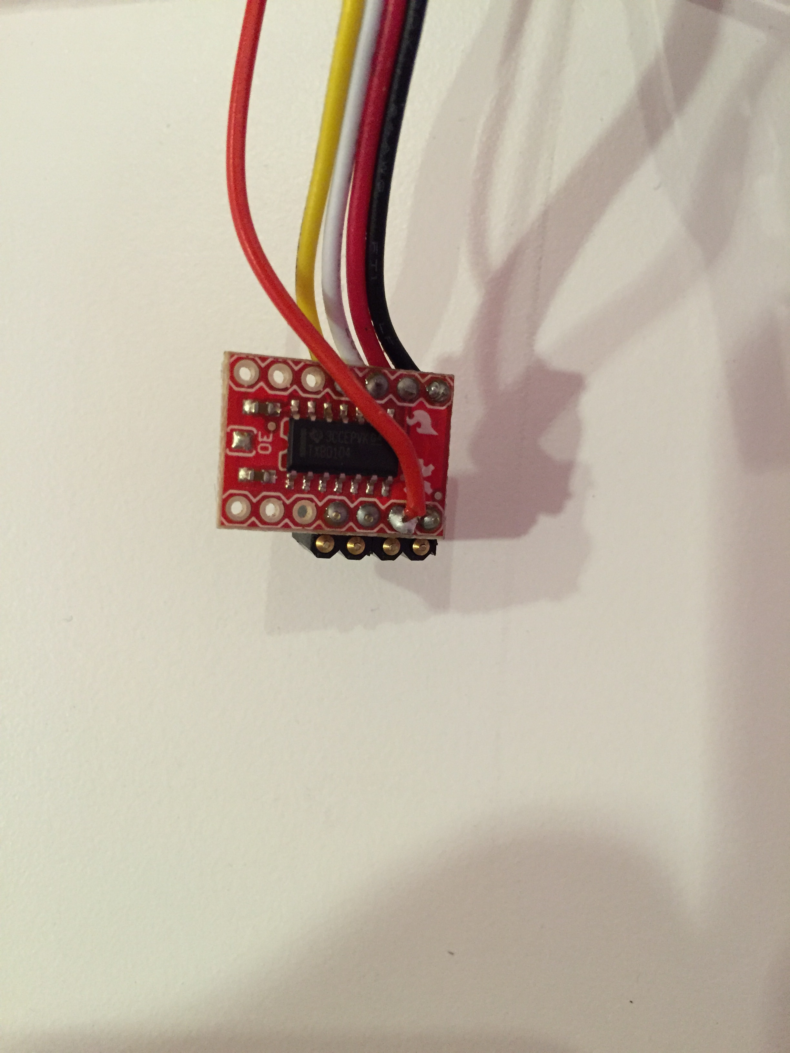

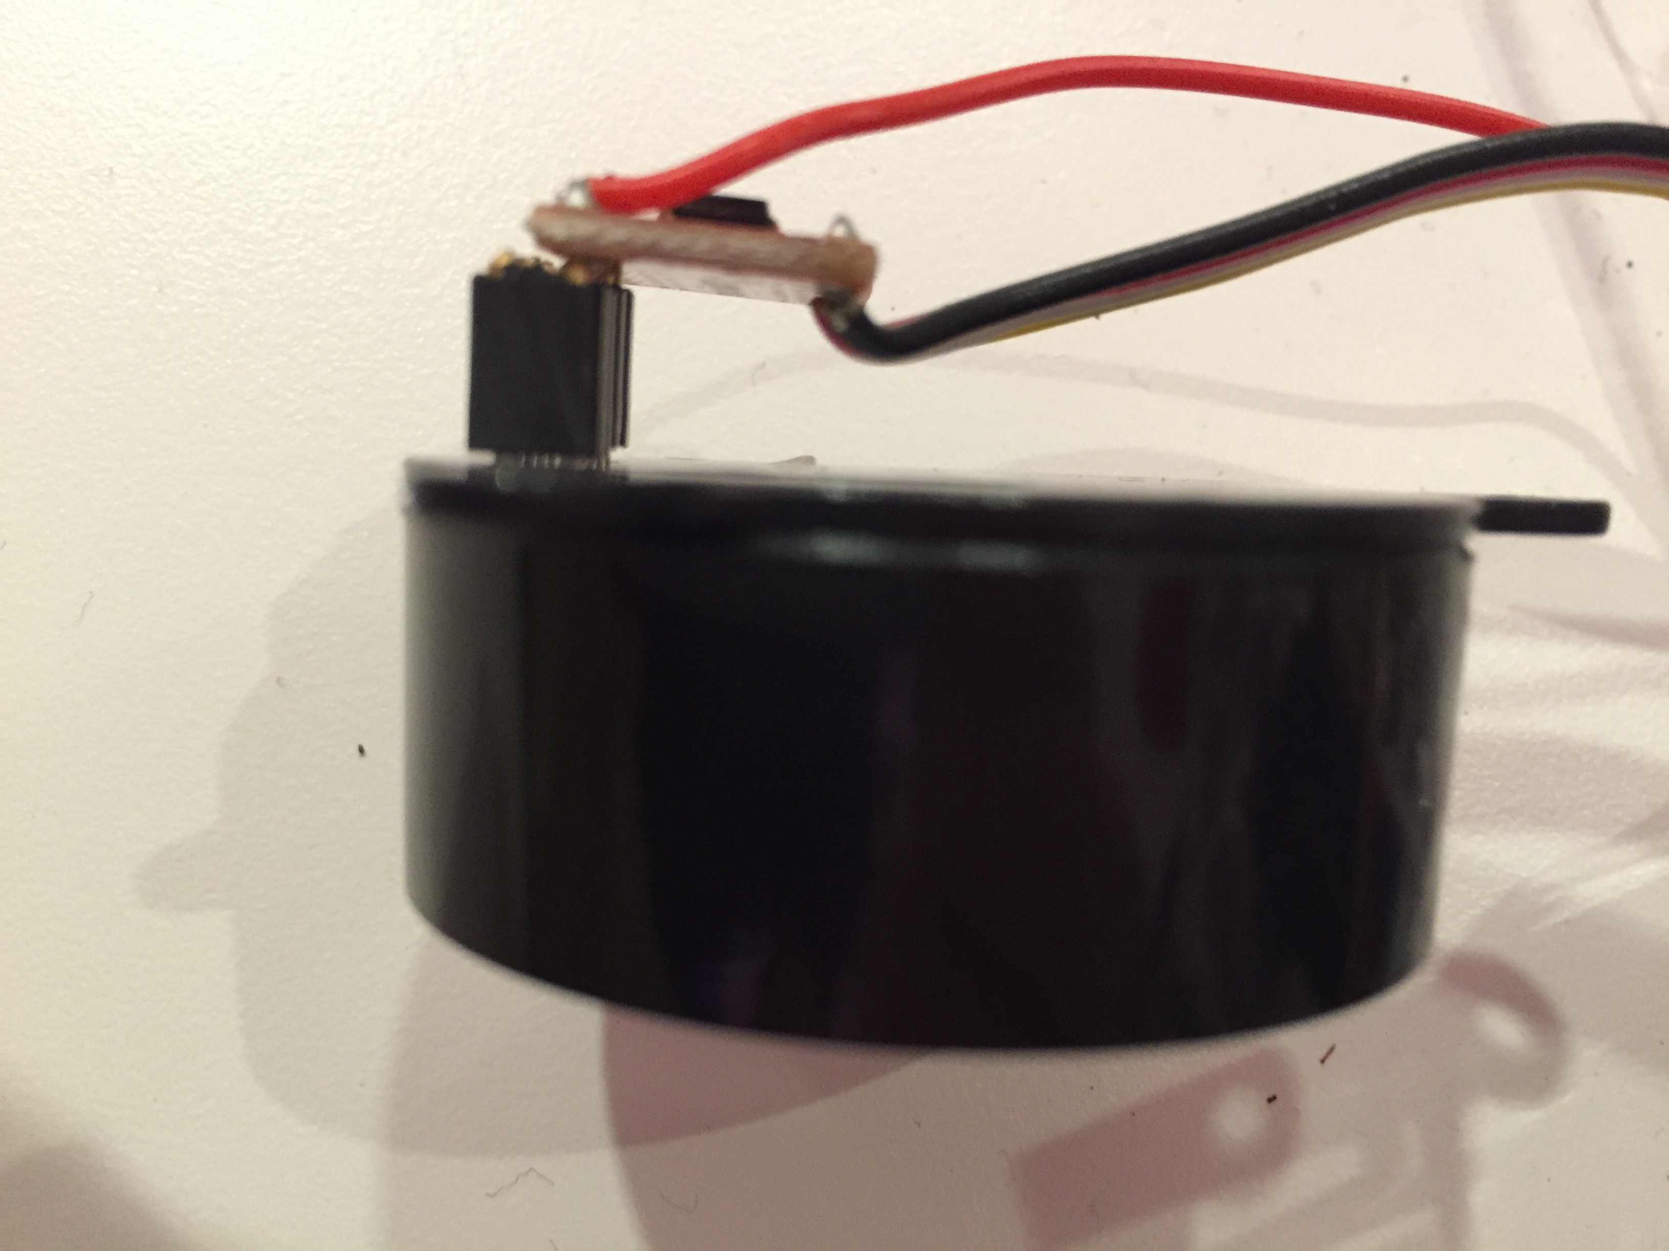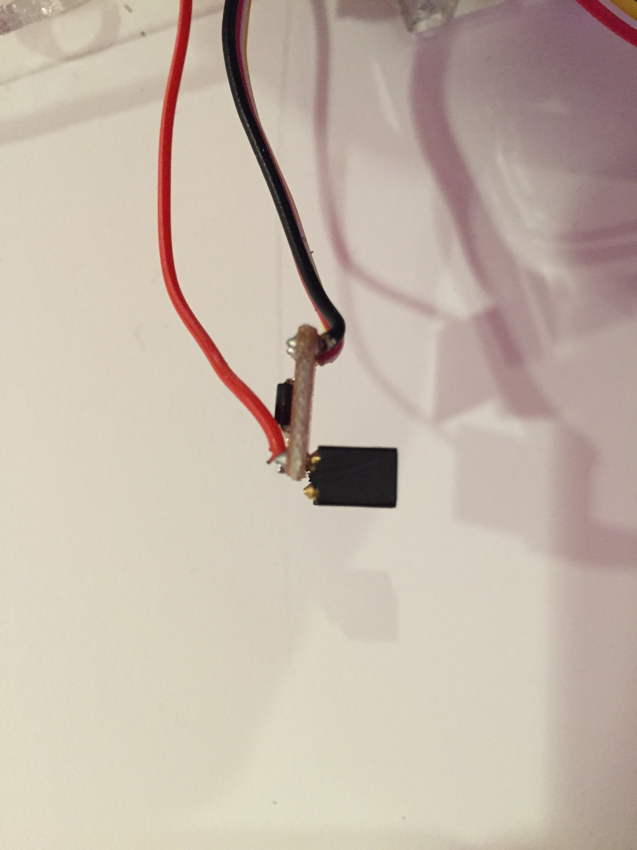

3.3V wire

Note that this row is not used

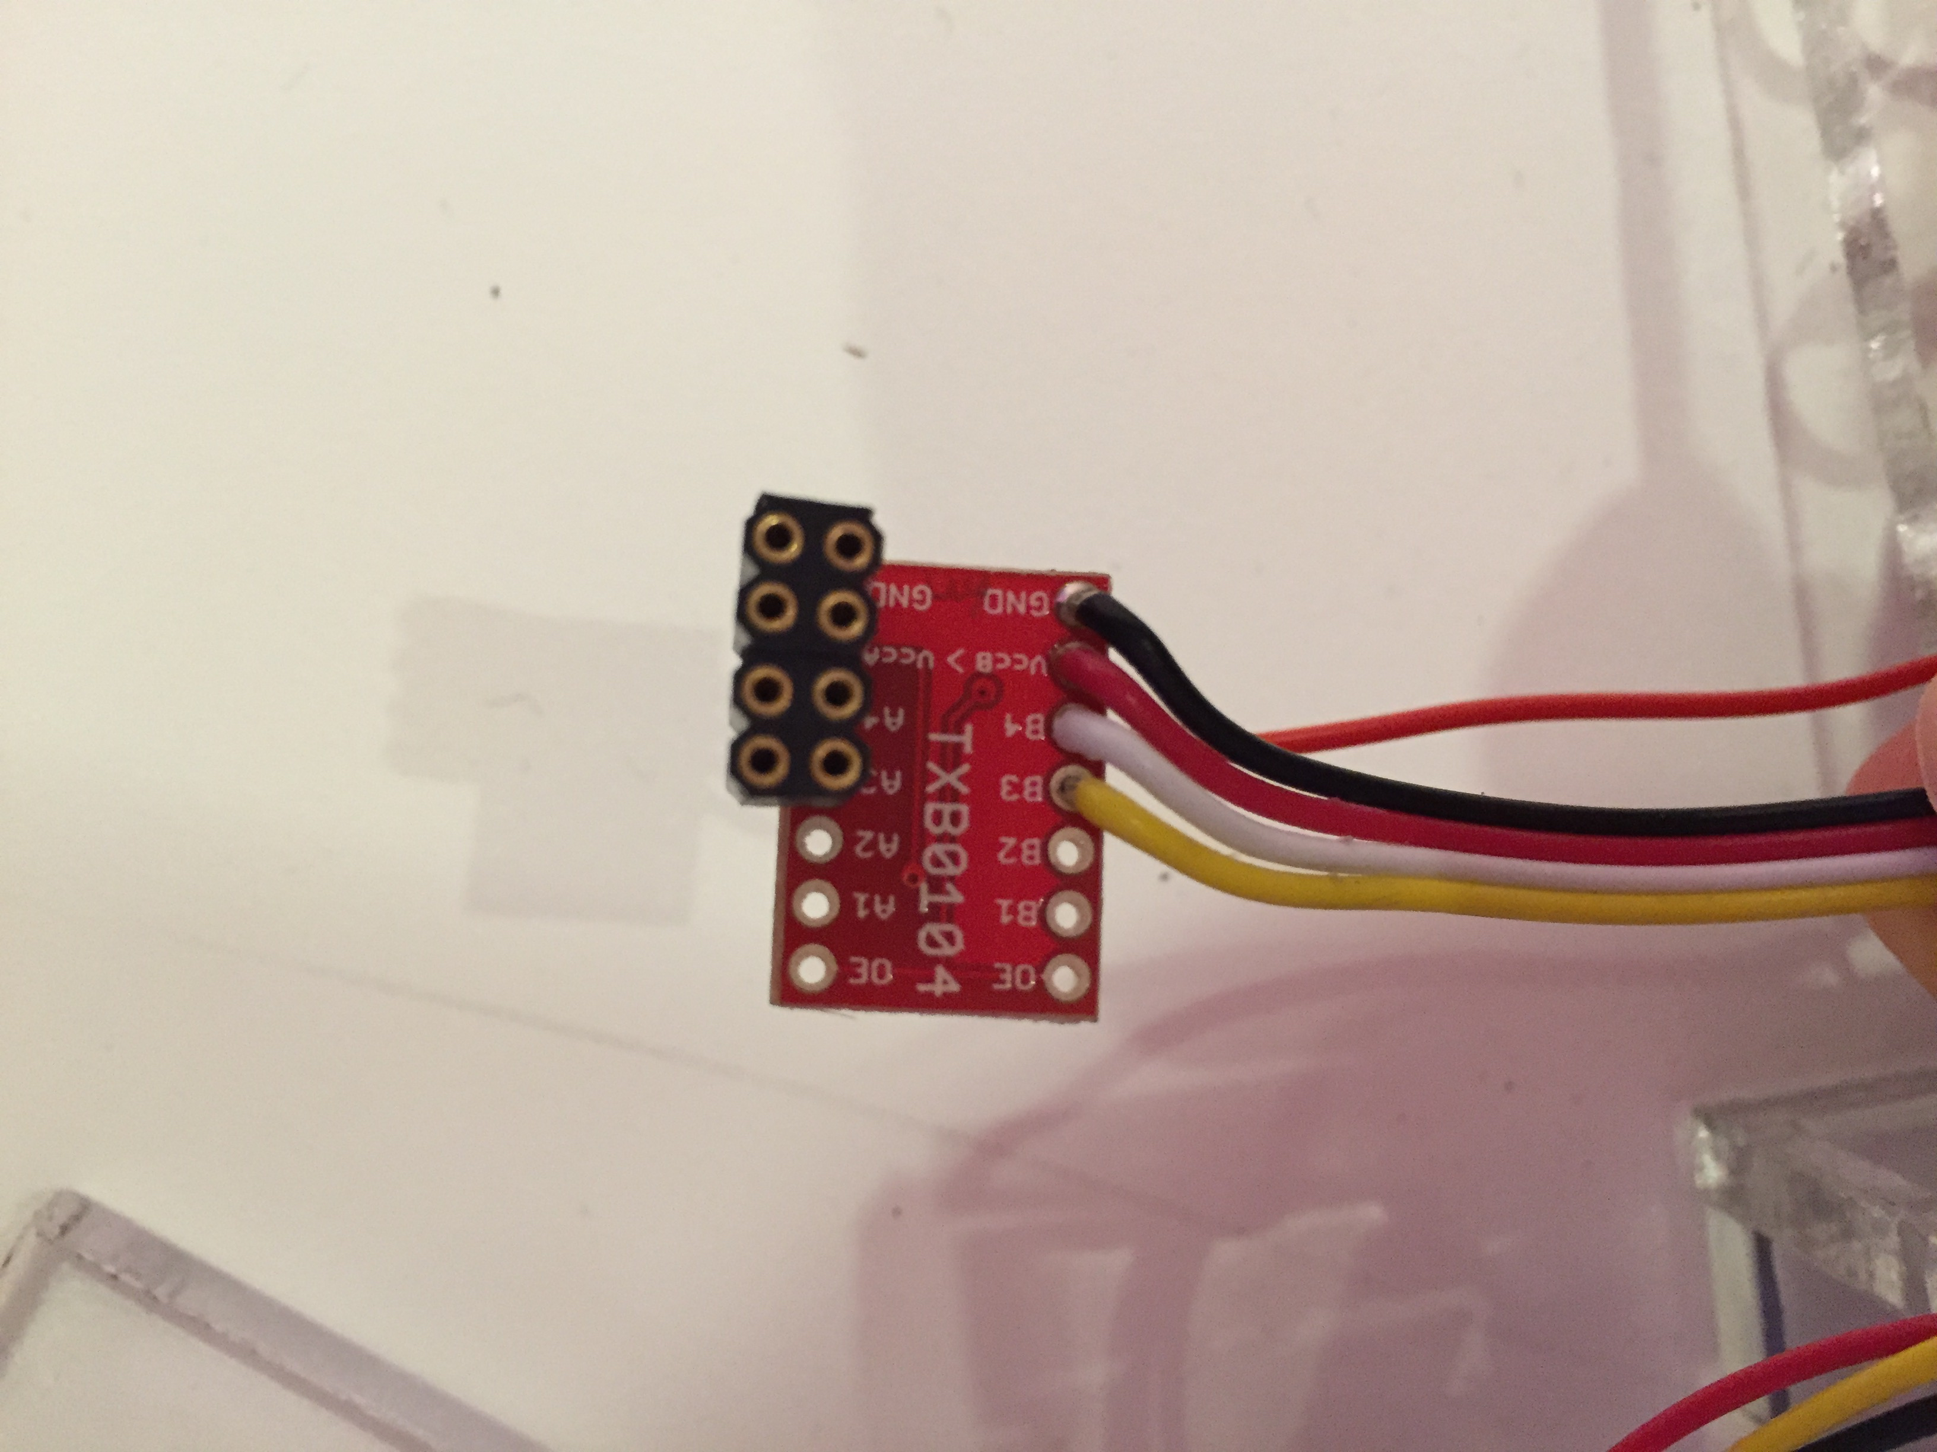

3. Solder wires to the Light, UV, IR sensor.

The Light, UV, IR sensor uses I2C communication, so 4 wires are needed (Gnd, 5V, SDA, SCL) The Grove cable provides these 4 wires:

SDA

SCL to Grove

5V Connector

GND

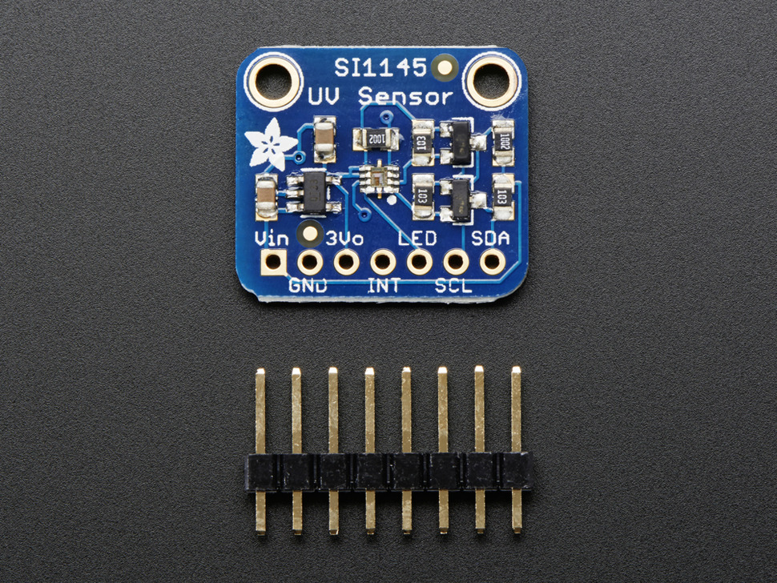

4. Install the sensors, on this example we’ve used Velcro, on the “column-sensor-side” acrylic panels, as such:

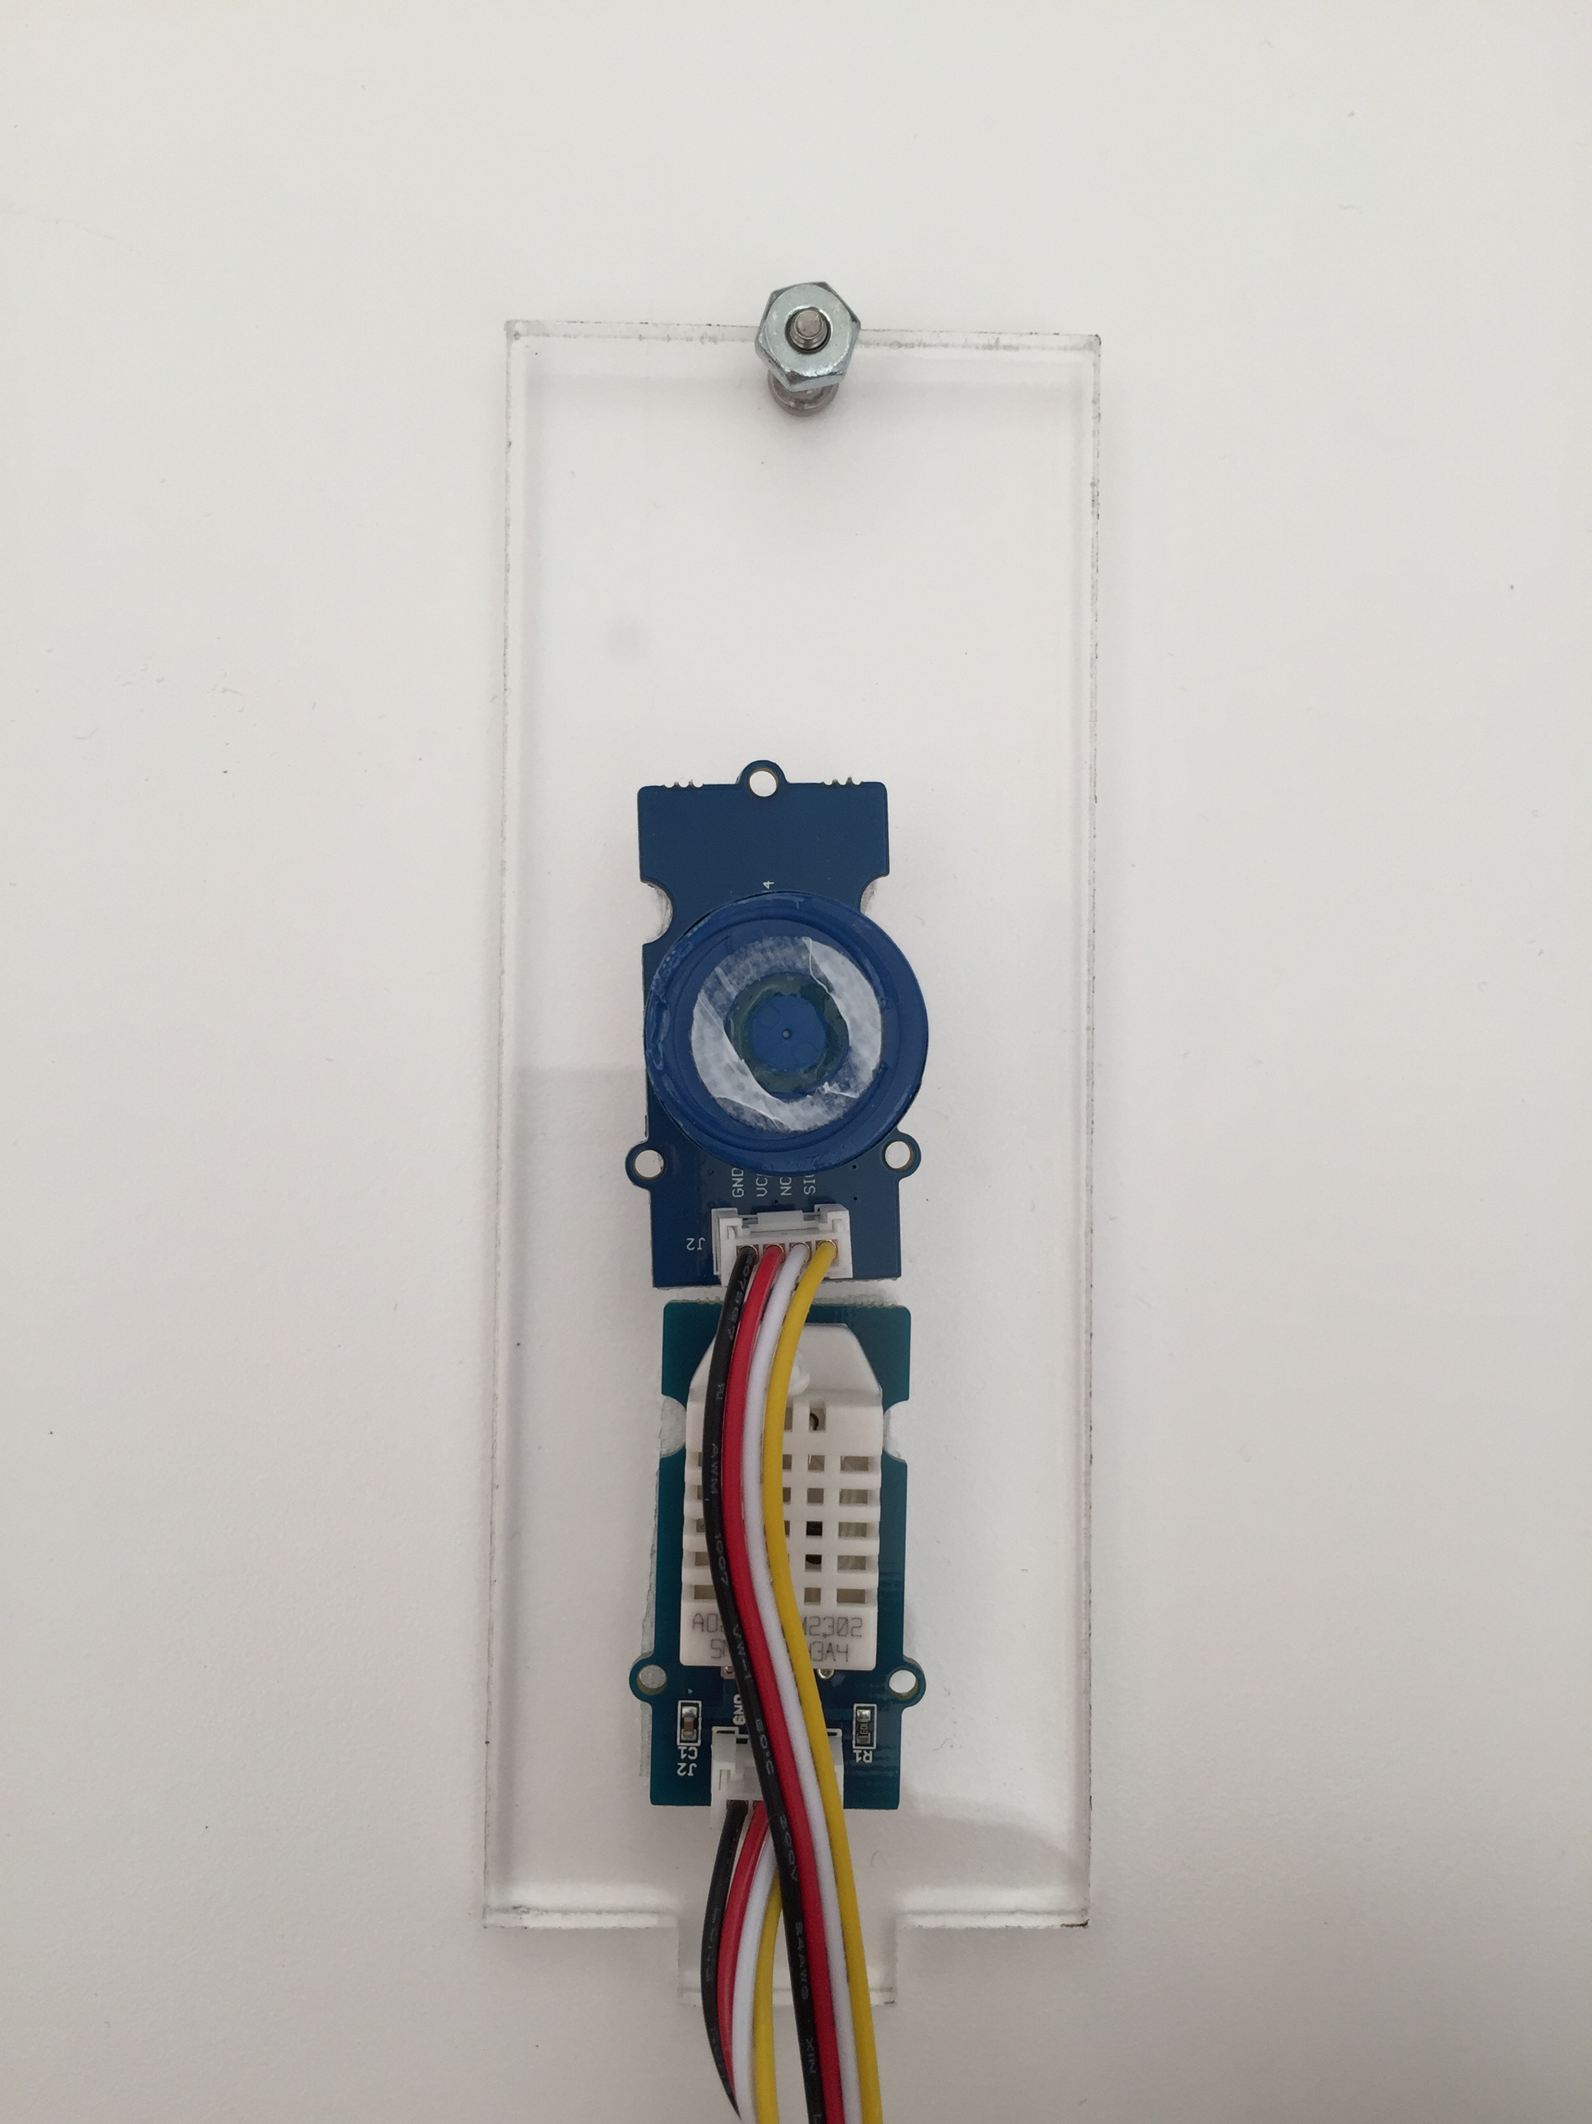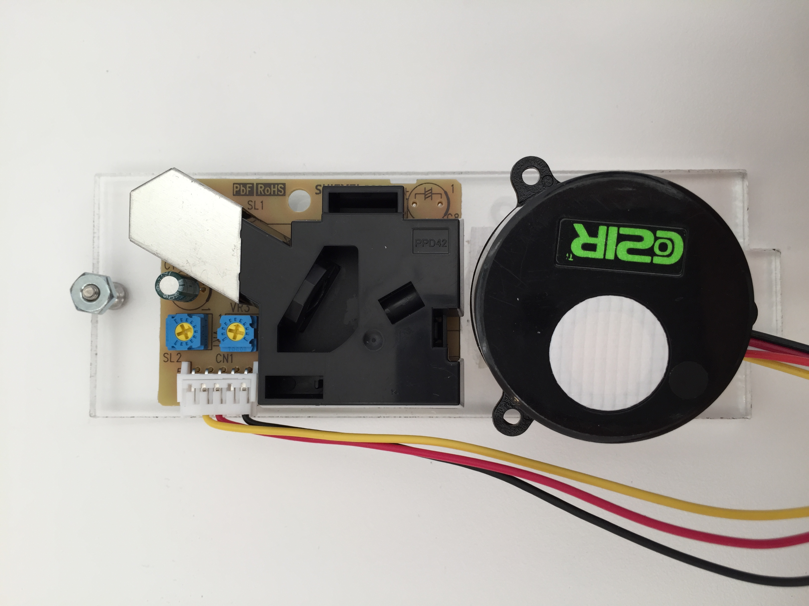

Dust Sensor

O2 Sensor

COZIR CO2 Sensor

Temperature and Humidity sensor

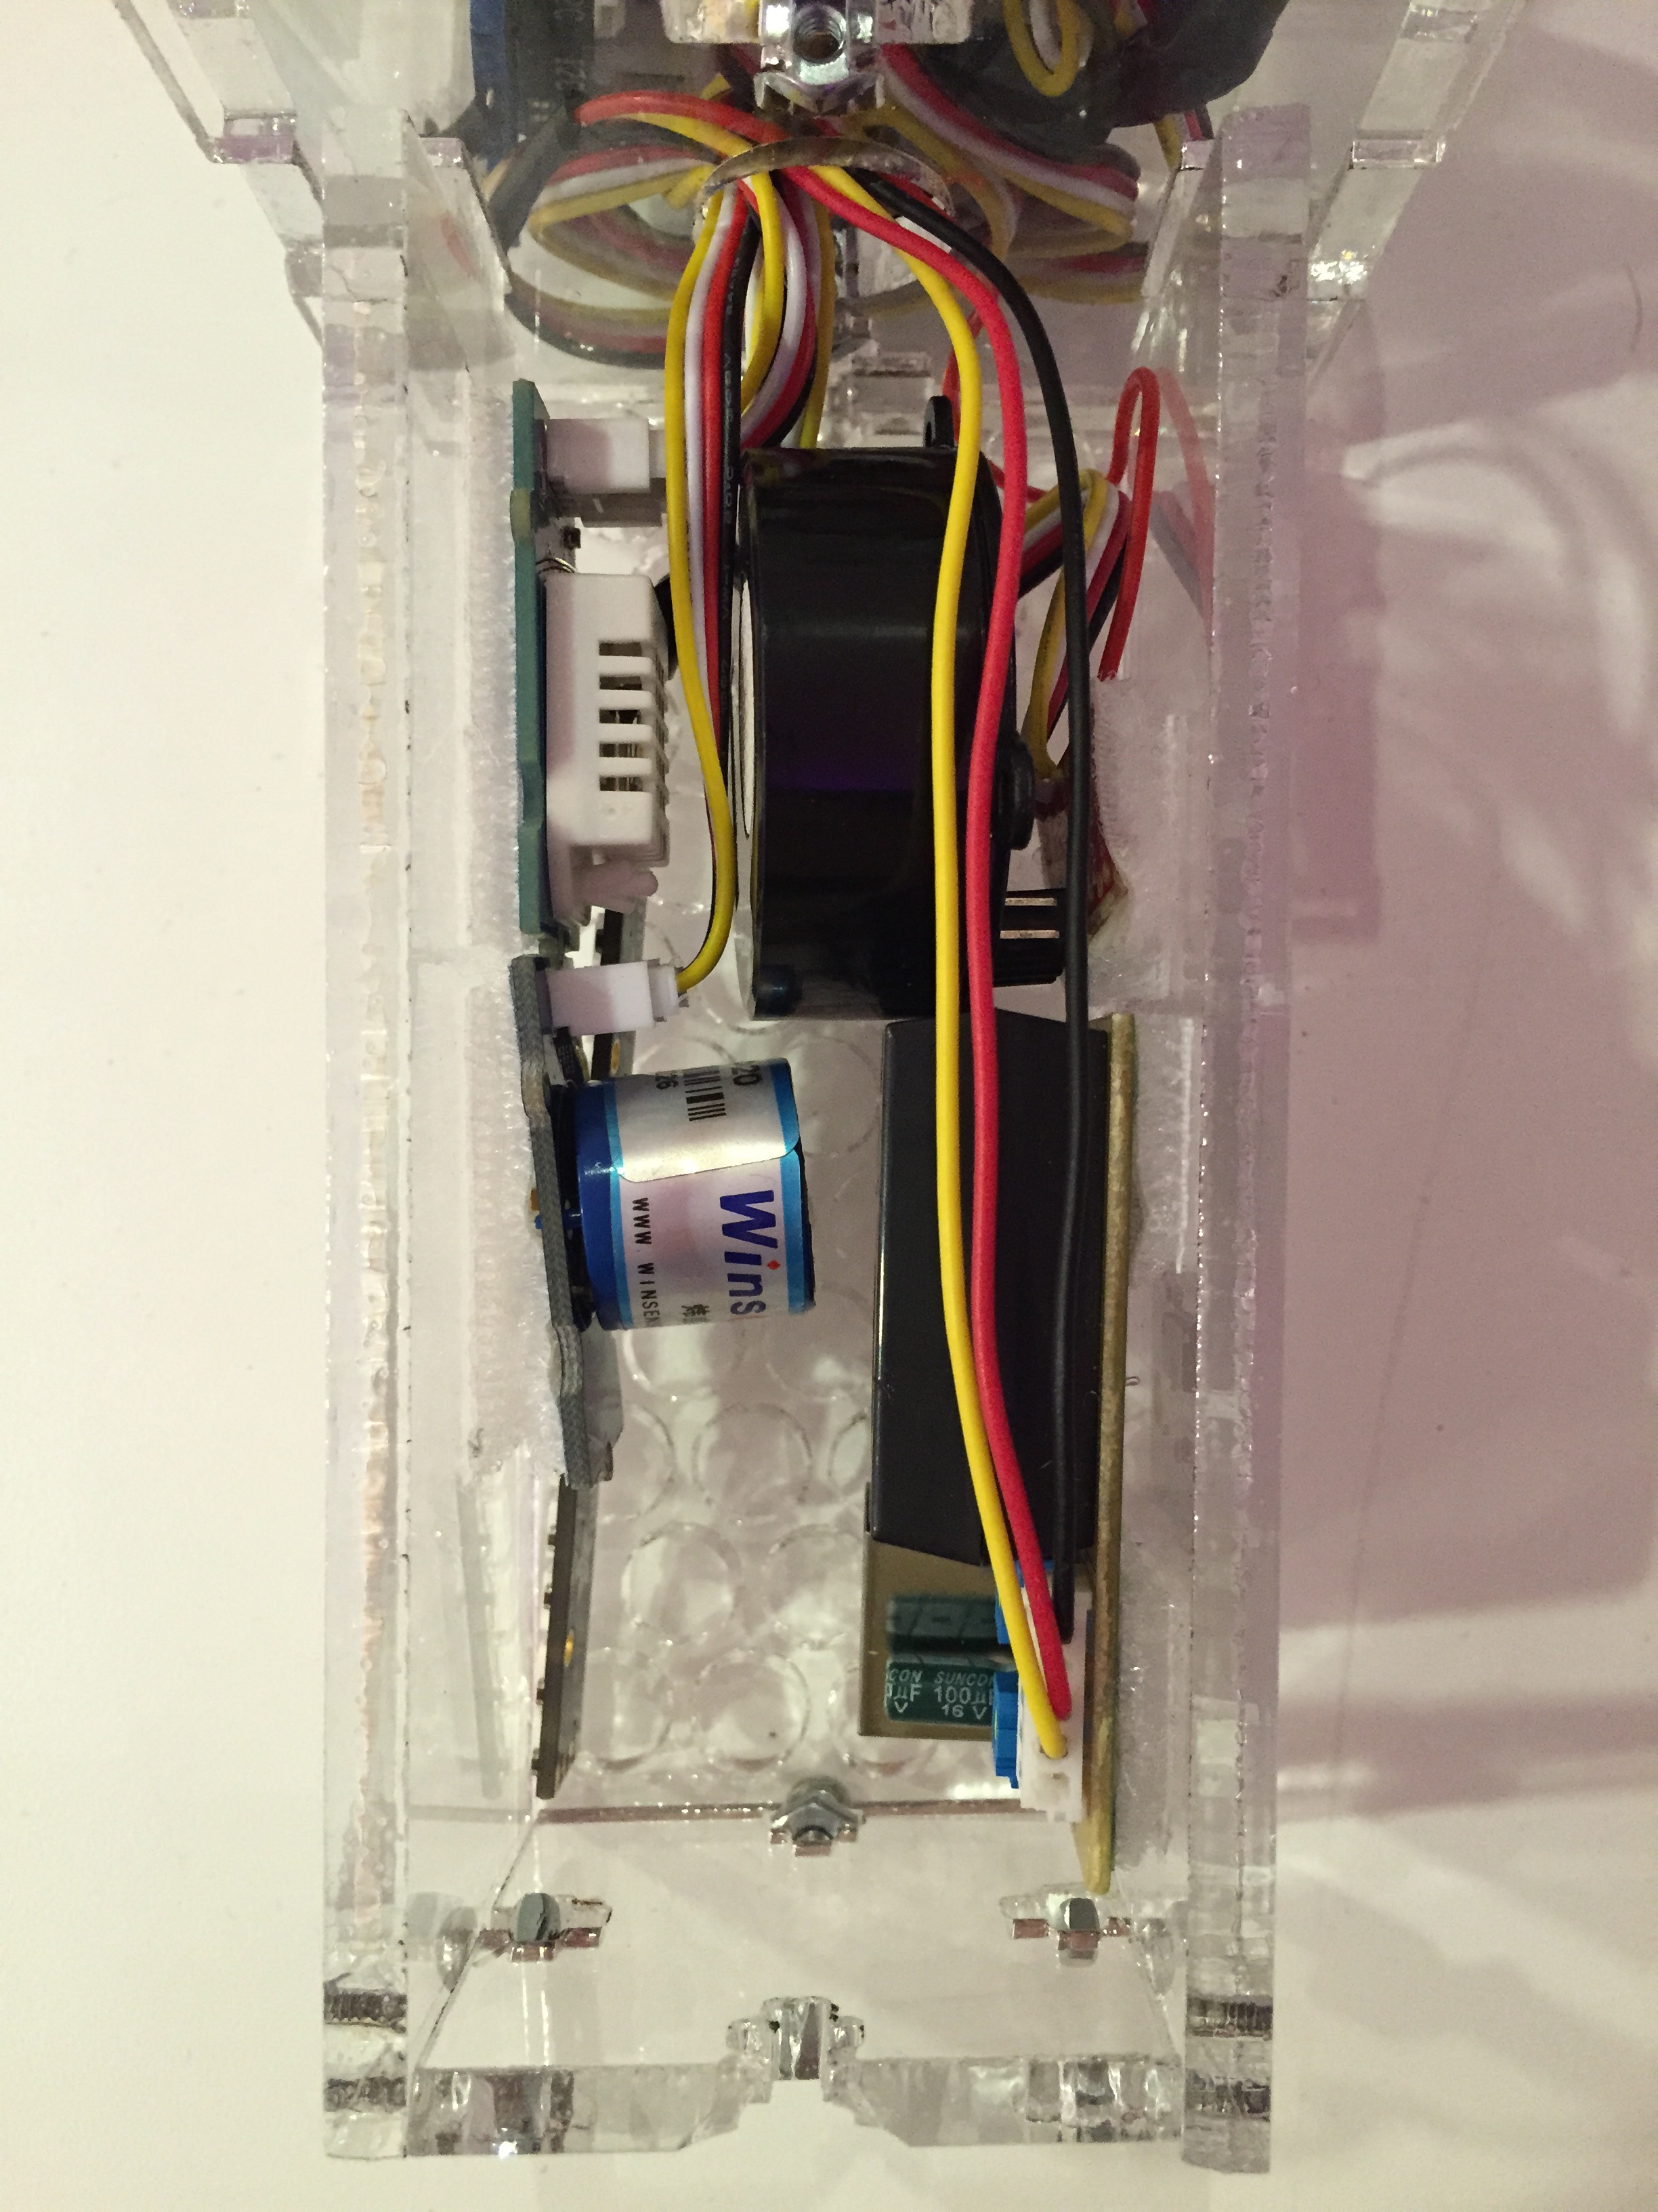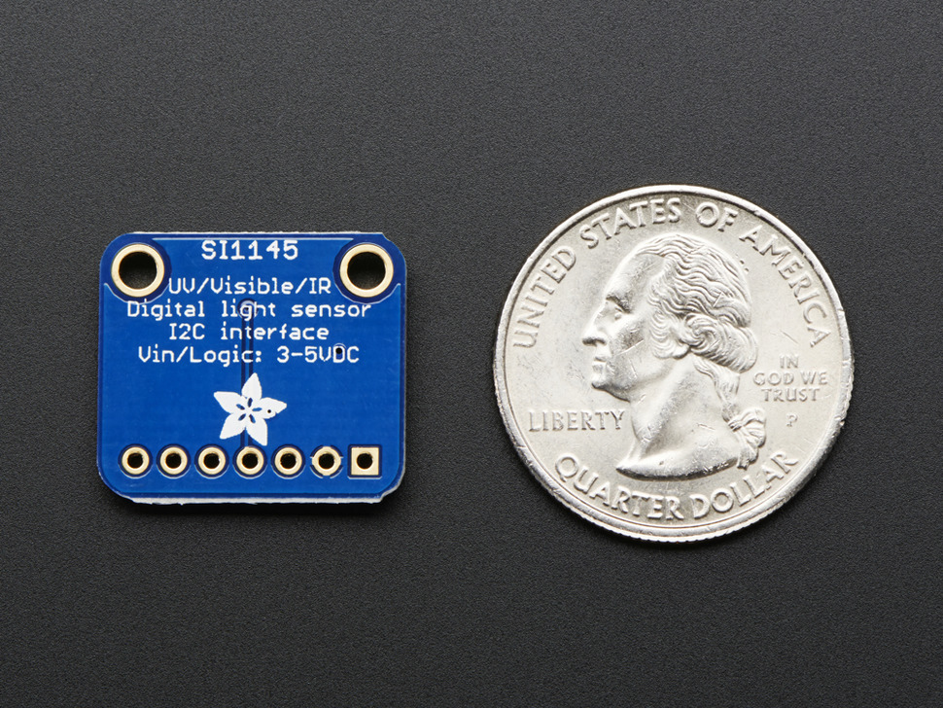

Light, UV, IR sensor

LED strip

The temperature probe cable must be routed before gluing the prongs to the “base-bottom” panel, since both the probe and the Grove connector are too large to route through once the prongs have been glued.

Epoxy or other suitable glue should be applied in the following regions:



After glue has been applied, insert the prongs in the “base-bottom” panel (make certain the temperature probe is in place first):

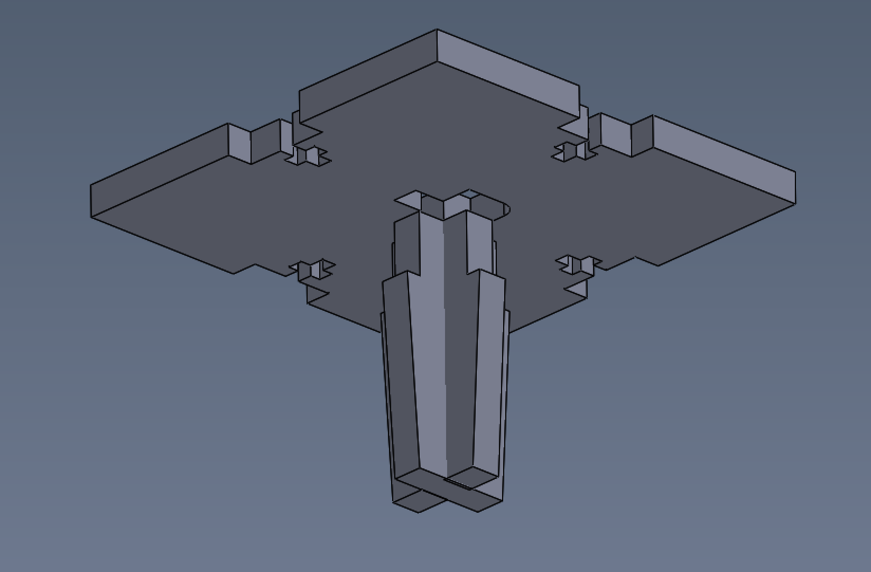

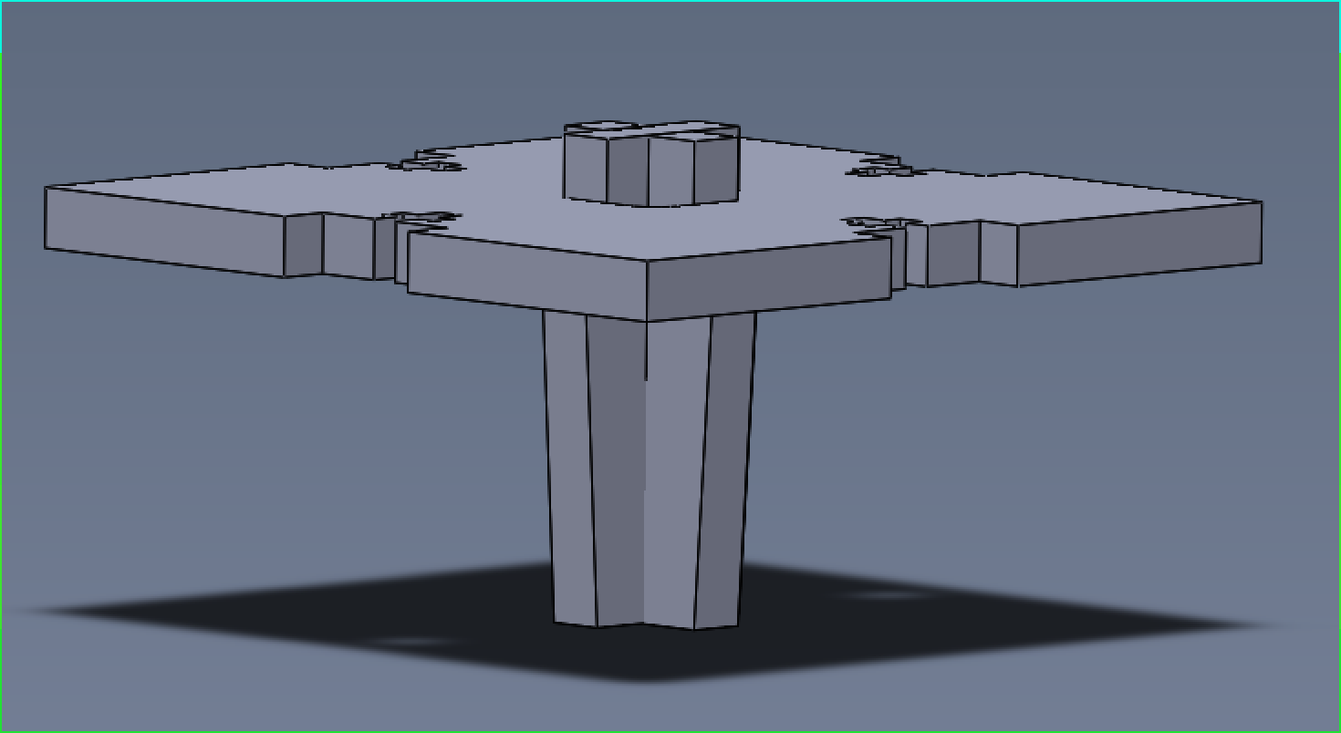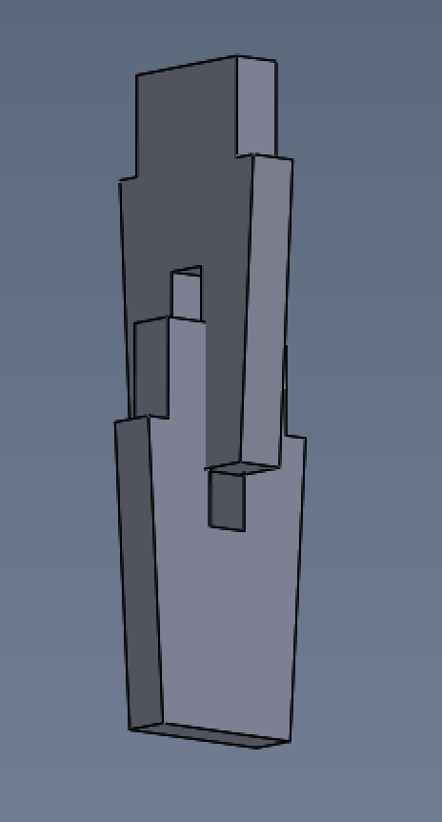

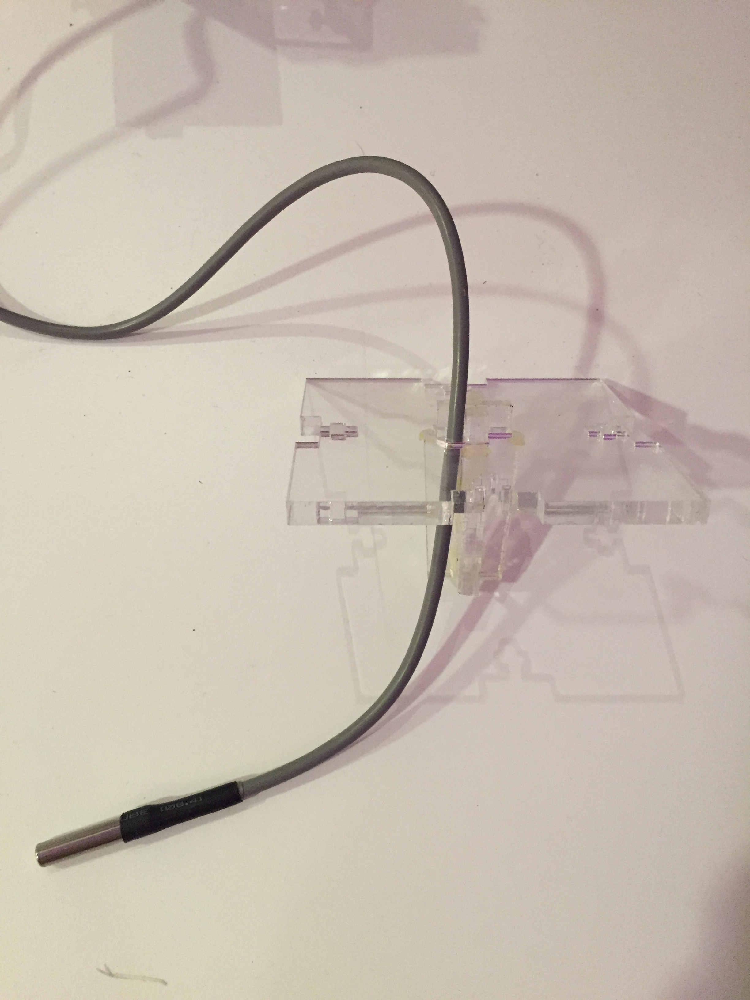

Temperature probe

Screw the “top”, “column-sides” and “column-sensor-sides” together, and insert the “base-top” panel while routing the Grove cables (One for each sensor, one for the LED strip, and one wire used to carry the 3.3V needed for the COZIR sensor) through the “base-top” center hole, as such:

Note: To screw the panels together using the T-Slot mechanism 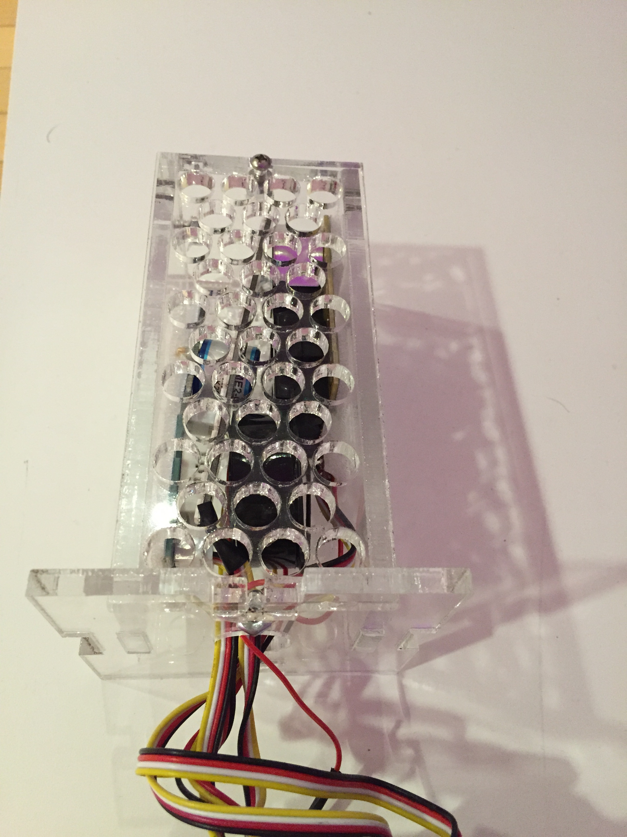simply:

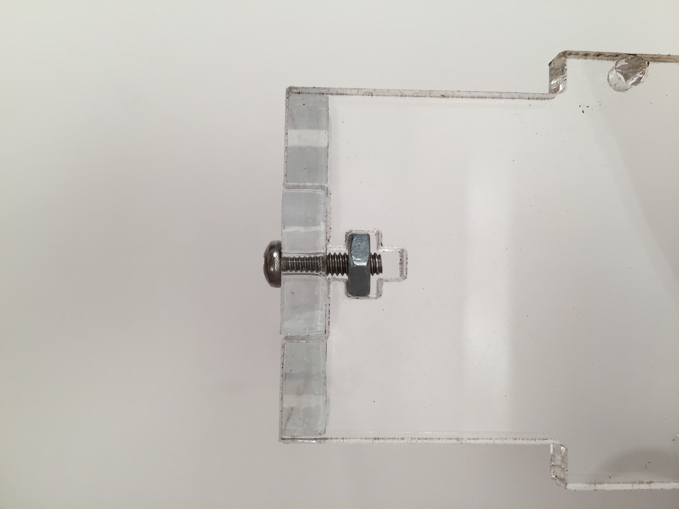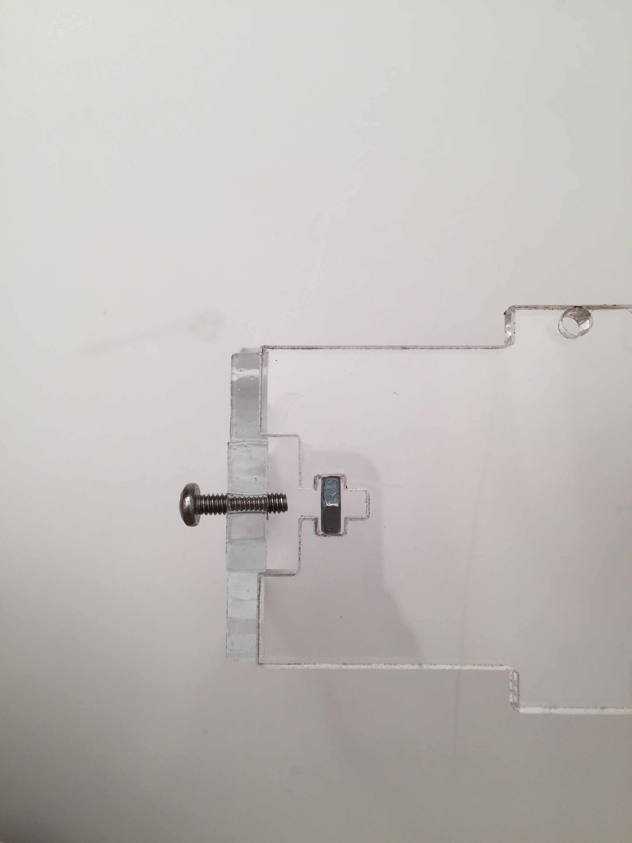

Fit the acrylic panels together and screw them in place

Insert the nut in the t-slot, and insert the screw in the hole corresponding to the nut inserted

4. Connect sensors to Grove shield using the Grove cables.

After the cables are routed, connect them to their respective ports:

|  |  |  |
| --- | --- | --- |
| Sensor: | Grove Port: | Arduino pin: |
| COZIR CO2 | D8 (also uses D9 as secondary pin, see note 2) | RX: D8, TX: D9 |
| O2 sensor | A0 | A0 |
| Temp. Humidity sensor | D4 | D4 |
| Temp. Probe | D6 | D6 |
| Dust sensor | D2 | D2 |
| Light, UV, IR sensor | One of the I2C ports | SDA A4, SCL A5 |
| LED Strip | D5 | D5 |
| COZIR 3.3V wire | 3.3V pin | 3.3V pin |

Note 1: The COZIR CO2 sensor RX pin (#3 on the sensor) is connected to the TX pin on the Arduino, and, similarly, the TX pin (#5 on the sensor) is connected to the RX pin on the Arduino. Both TX and RX pins are be defined in the code, since Software Serial is used (#define CO2_SENSOR_RX and #define CO2_SENSOR_TX set the pins used for TX and RX by the Software Serial Object).

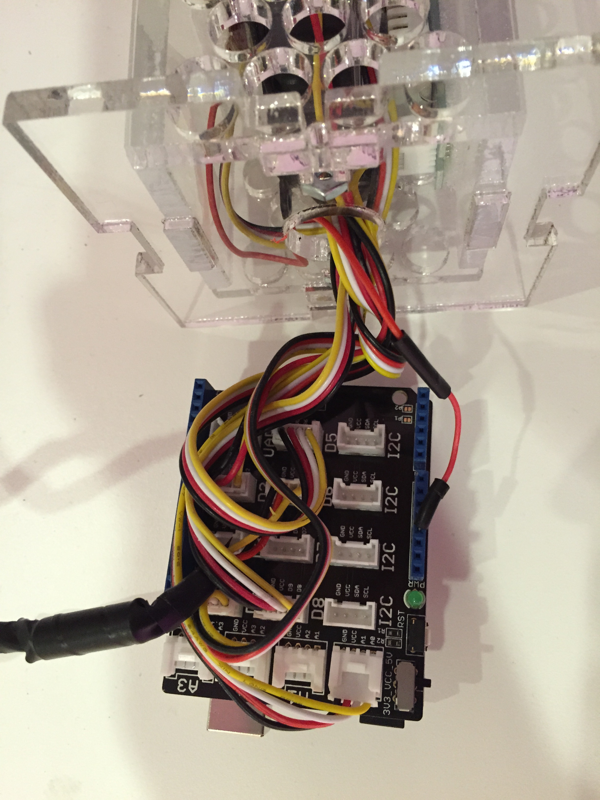

3.3V wire for the COZIR CO2 sensor

Note 2: The Grove ports are named based on the respective Arduino port used, however, a secondary pin is connected to the next numbered port, and this port may or may not be used, depending on the needs of the sensor (The COZIR sensor, for example uses both pins), and so, 2 Arduino ports may be used by the same Grove port, that is, Grove port D8, for example, is connected to both Arduino’s ports D8 and D9, and so, Grove port D9 CANNOT be used, if the sensor uses both ports, since it’s connect to Arduino’s ports D9 and D10.

5. Plug the shield into the Arduino, and finish assembling case.

Connect the shield to the Arduino, and screw the side panels to the “base-top” panel.

Note that the “base-top” panel is attached to both the “base-side” panels and the “column-side” panels by 2 1” long 4/40 screws.

Note that the Arduino USB port must be aligned with the “base-side-usb” panel

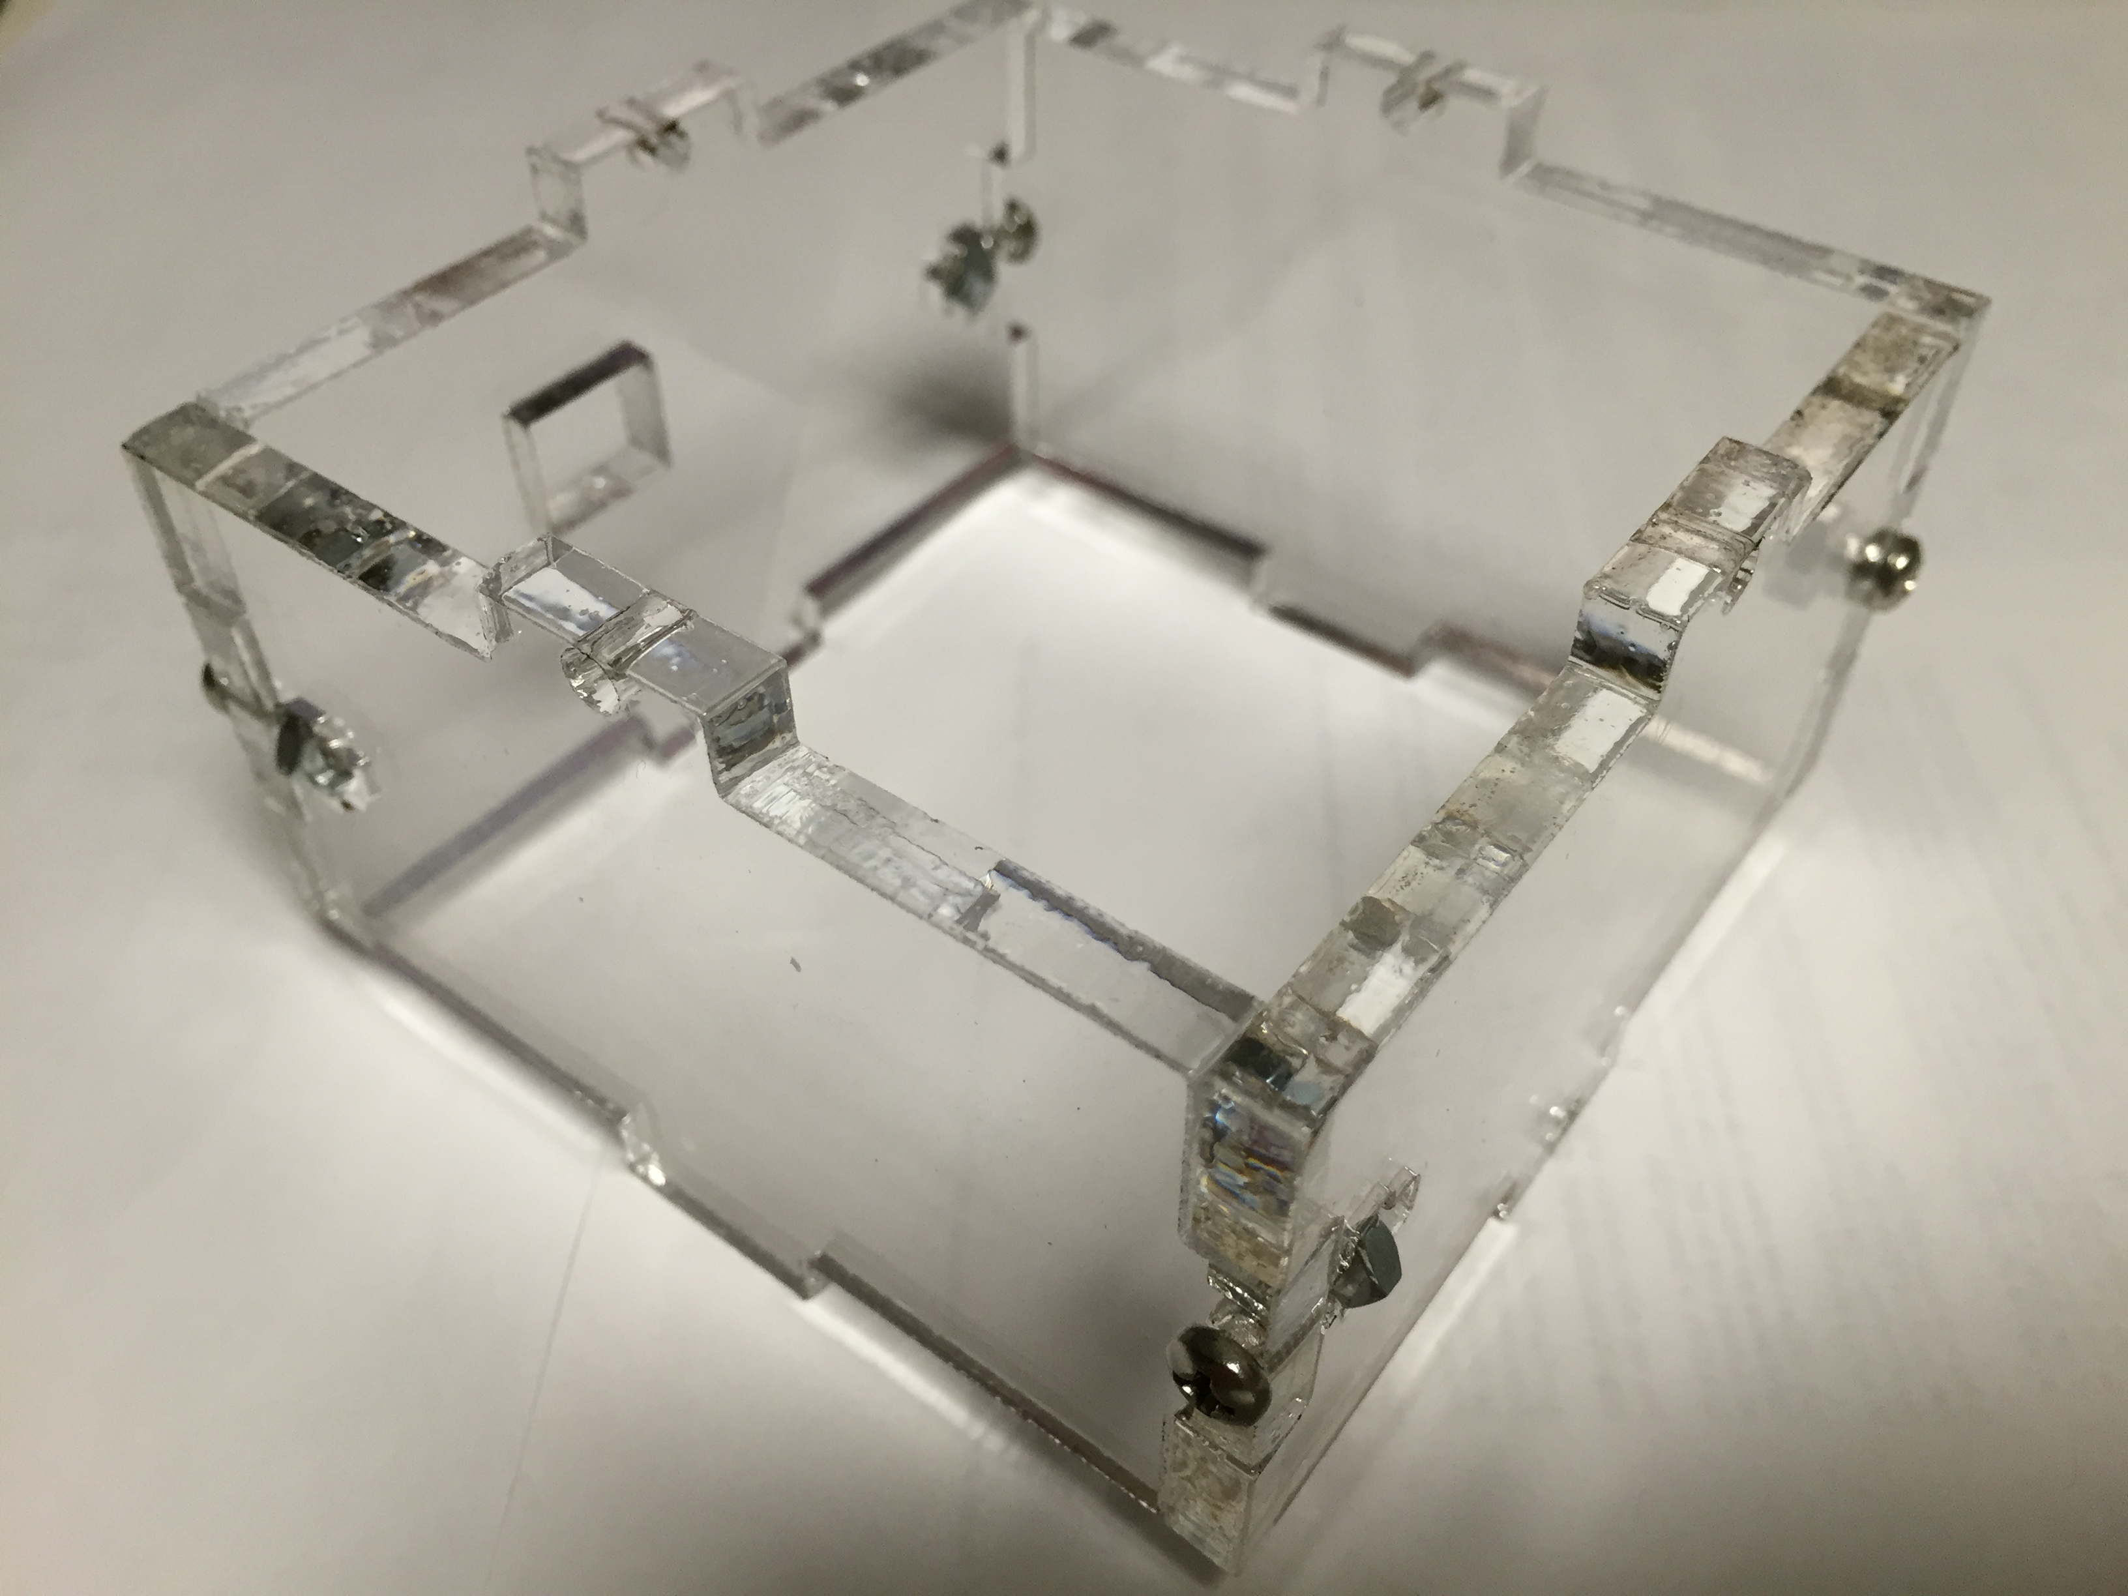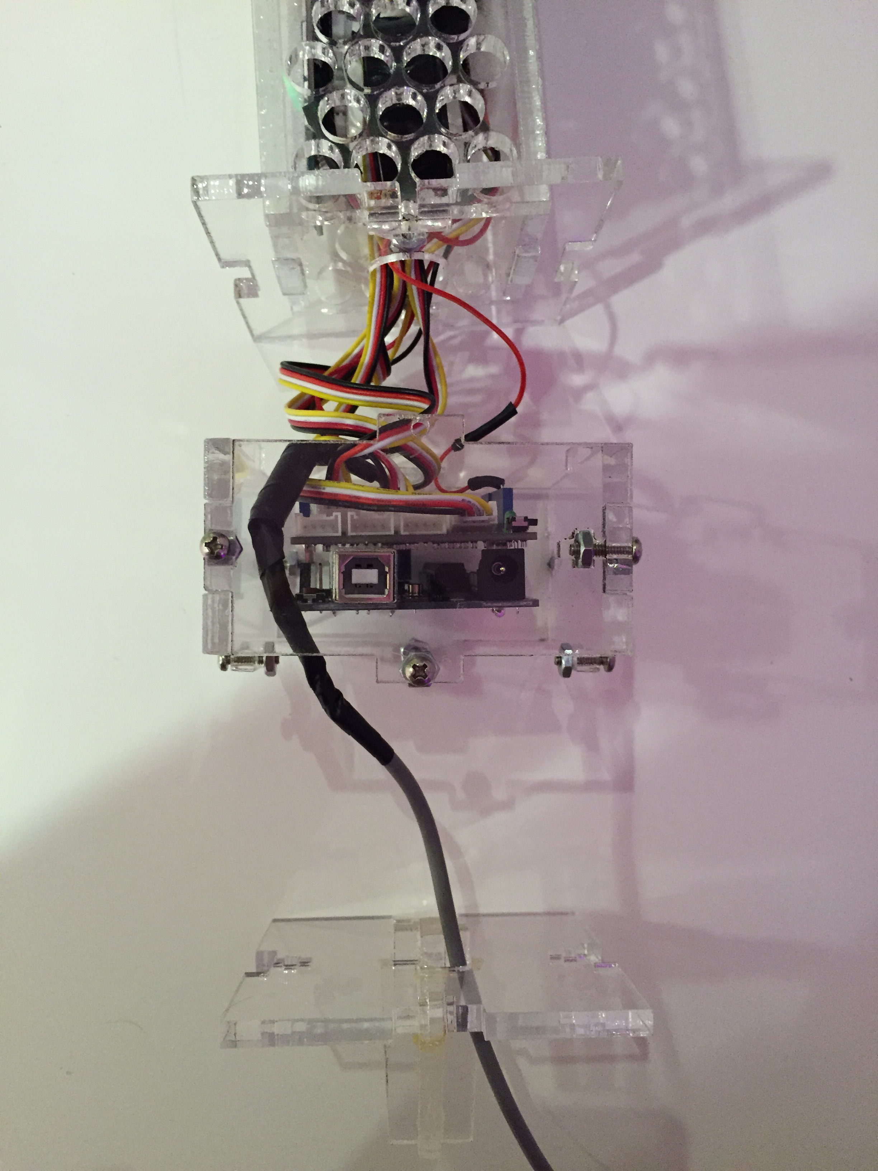

1” screws

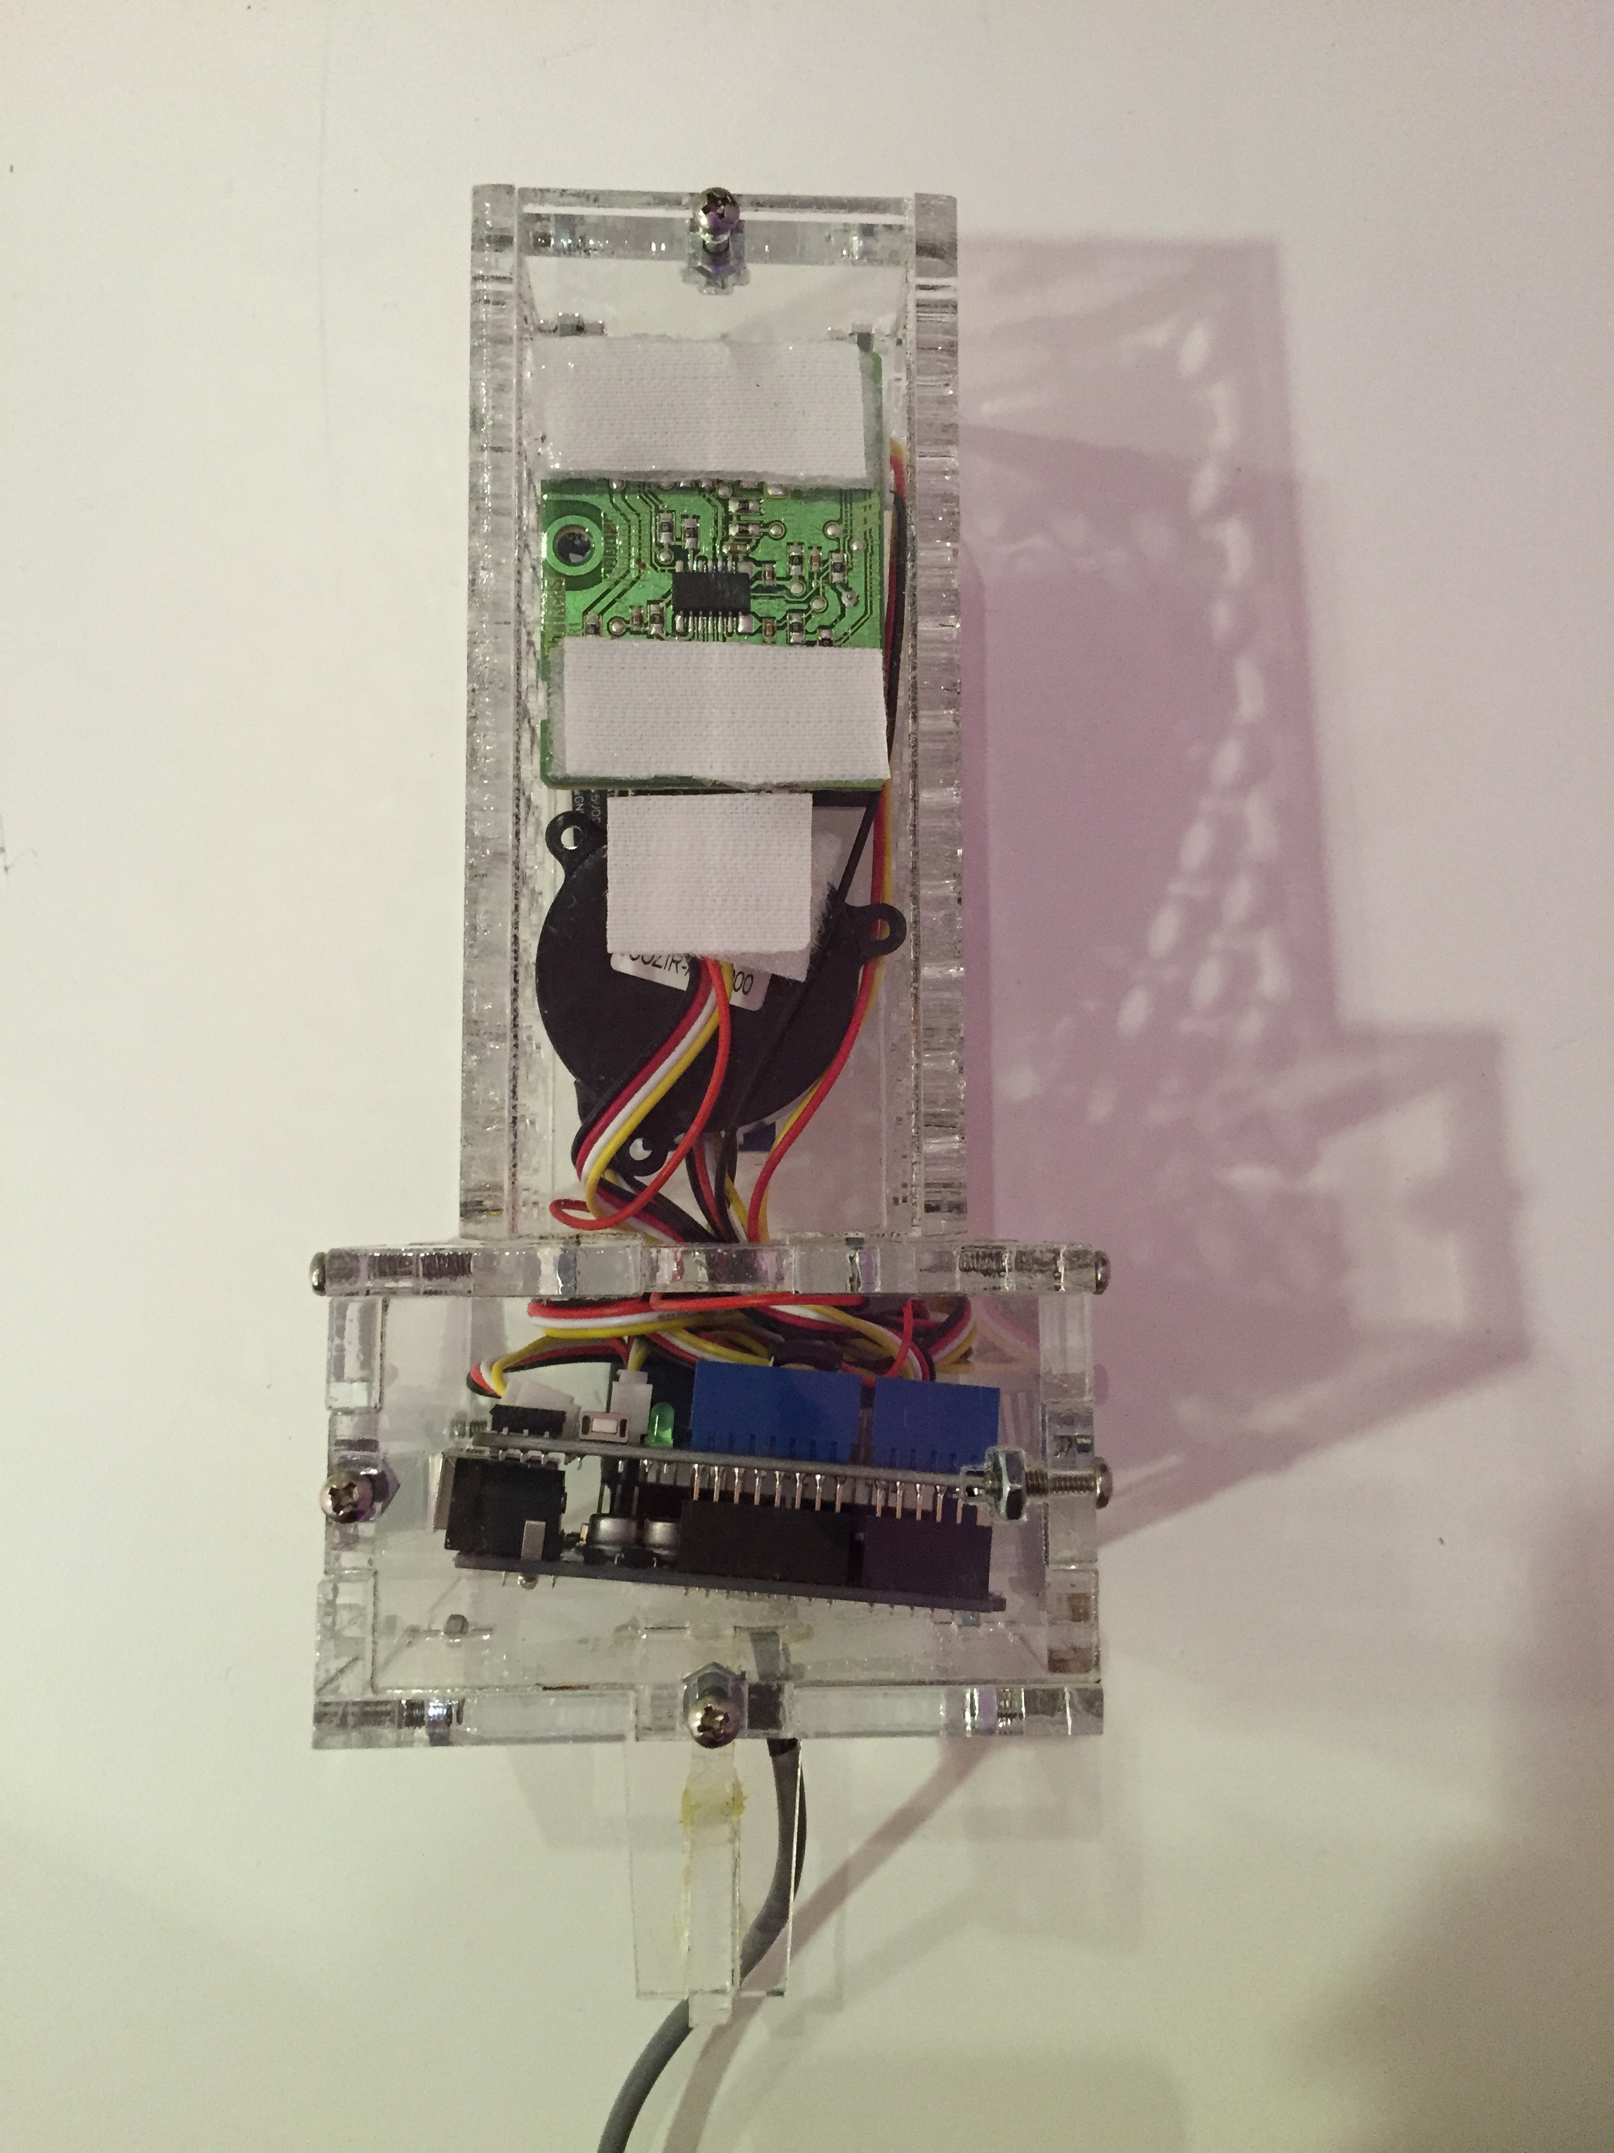

Side panels, base-top and base-bottom screwed in place

Side panels, base-top and base-bottom before being screwed in place

Side panels screwed together

Finished board:

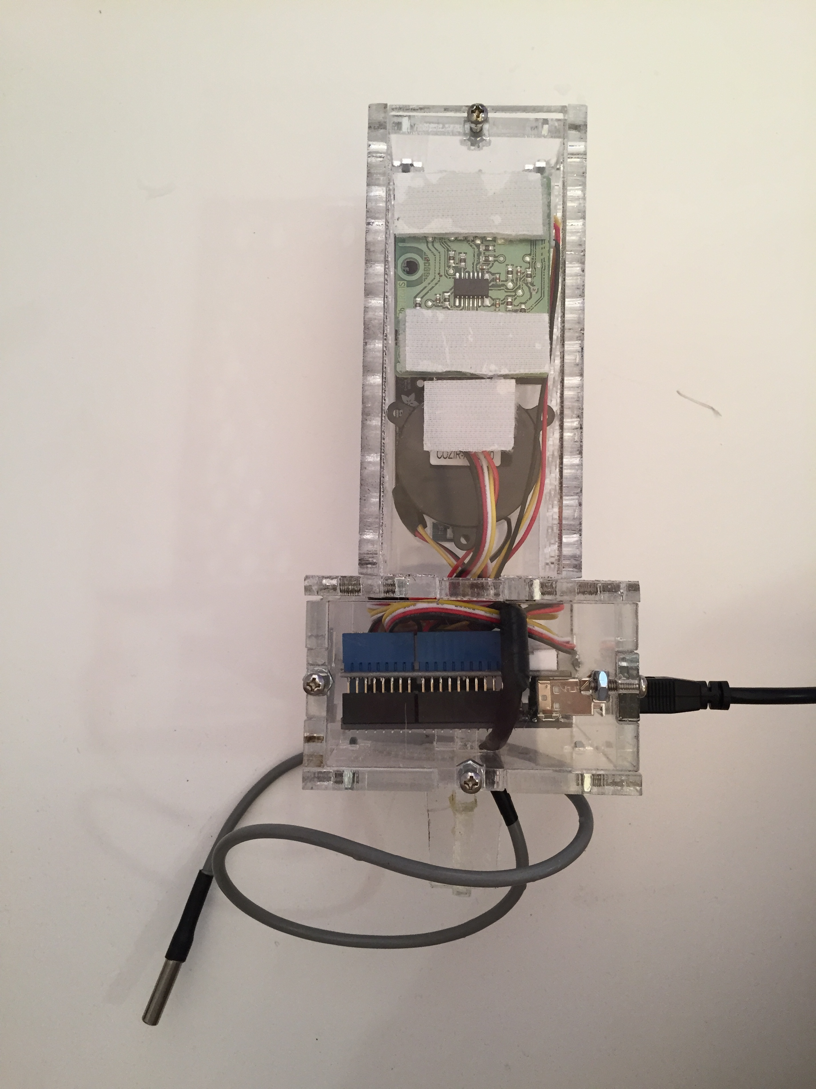

5. Program board, connect it to a Raspberry Pi and follow the “Water-Air Board Deployment Guide”

To program the board, simply connect a USB cable from the Arduino to a computer with the Arduino IDE software installed [10], download and open the provided “Air_Board” Arduino project, and upload the code to the Arduino.

To program the board using the Arduino IDE, do as follows:

Open the Arduino IDE, select File 🡪 Open… 🡪 (Go to the path of the downloaded “Air_Board” folder) Select Air_Board.ino and hit Open.

Go to the menu Tools 🡪 Board 🡪 Select the Arduino board being used (in this example, the Arduino Uno)

Go to the menu Tools 🡪 Serial Port 🡪 Selec the serial port corresponding to the Arduino device connected. If it is not known, you may try removing the Arduino, checking the available ports in the ‘Tools 🡪 Serial Port’ menu, inserting the Arduino and then checking the ‘Tools 🡪 Serial Port’ menu again. The new device that appeared, and wasn’t available before is most probably the Arduino.

Click the Arrow button to compile and upload the program, alternatively you can use the File 🡪 Upload menu.

After the program has uploaded, you can try acquiring data from the board by opening the serial monitor (Tools 🡪 Serial Monitor), set the proper baud rate (9600 in this example) and line ending (CR in this example) and send the ‘r’ command, to do that just type ‘r’ (without quotes) and hit ‘send’, after a few seconds the board will return the measurements in the following order:

“CO2, Light, UV, IR, O2, Water_Temperature, Temperature, CO2_Temperature, Humidity, CO2_Humidity, Dust”

If everything is working, you can proceed deploying the Air Board using the “Water-Air Board Deployment Guide”.

For more information about the Air Board, read the “Air Board Documentation” file.

References:

[1] <http://www.co2meter.com/collections/co2-sensors/products/cozir-0-2-co2-sensor>

[2] <http://www.seeedstudio.com/depot/Grove-TemperatureHumidity-Sensor-Pro-p-838.html>

[3] <http://www.adafruit.com/products/1777>

[4] <http://www.seeedstudio.com/depot/One-Wire-Temperature-Sensor-p-1235.html?cPath=25_27>

[5] <http://www.seeedstudio.com/depot/Grove-Gas-SensorO2-p-1541.html>

[6] <http://www.adafruit.com/products/1426>

[7] <https://www.sparkfun.com/products/11771>

[8] <http://www.seeedstudio.com/depot/base-shield-v13-p-1378.html?cPath=132_134>

[9] <https://github.com/MIT-CityFARM/sensor-board/tree/master/Air%20Sensors/CAD>

[10] <http://arduino.cc/en/main/software>